Dog Attacks on Postal Workers - Example Cases
WARNING – GRAPHIC IMAGES
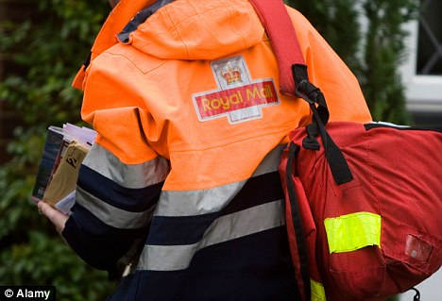

Complied by  Dave Joyce  Communication Workers Union  National Health, Safety & Environment Officer |  | Version 5 – Aug 2016
Anthony Quinn  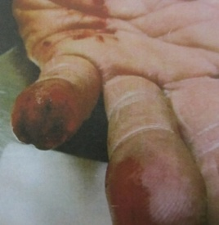  Barrow postman Anthony Quinn lost the top of his finger when a dog bit him from the other side of the letterbox as he was delivering mail in Lancaster in October 2011. "There was no sound from inside to warn me of a dog's presence and as I pushed the letter in I was bitten," Anthony recalls, adding: After being rushed to hospital in nearby Preston, doctors told him that they would have to amputate below the nail root of the small finger of his left-hand. | Patricia Prew  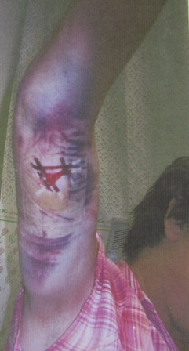  Exeter Postwoman Patricia Prew's extensive bruising and deep flesh wound were inflicted on her by a Golden Retriever, which attacked her as she entered the front garden of a house in Devon. Patricia was delivering mail in Budleigh and had just come through the gate when the dog "came running at her from the side of the house and jumped at her grabbing hold of her and pulling her down ripping off a chunk of her arm muscle.
Andrew Berge  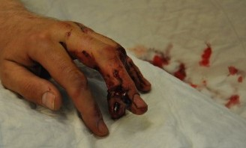  South London Postman Andrew Berge suffered severe damage to his left-hand ring finger and tendon In August 2011. There was no warning. As he posted an item through the letterbox, a Staffordshire Bull Terrier dog bit into his fingers and held on for four to five minutes before ripping flesh from his fingers causing serious flesh, muscle, tendon and ligament damage before letting go. | Jason Lee  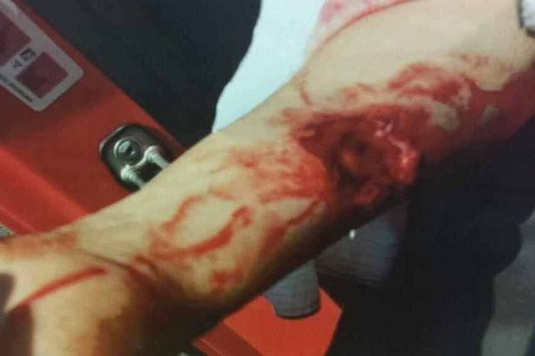  Huddersfield postman Jason Lee needed plastic surgery on his arm In July 2013 after being badly mauled in a horrific dog attack in the Huddersfield village of Meltham left him with a 'life changing' injuries. Jason suffered a terrible injury, tearing a large chunk of muscle and flesh from his forearm as he protected his face when the dog struck. The 41-year-old was rushed to Huddersfield General Hospital and then transferred to specialist unit at Bradford Royal Infirmary where he underwent plastic surgery.

Elaine White  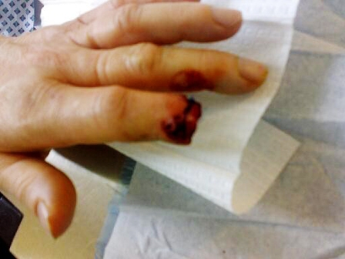  Wakefield Postwoman Elaine White had the top of her finger bitten off while delivering an item of mail in Wakefield, Yorkshire, in April 2008. While an ambulance took the postwoman to hospital, police arrived at the scene and, having gained access to the house, were able to recover the severed finger. However, although the officers rushed the digit to the hospital, it had been damaged so severely that surgeons were unable to reattach it leaving Elaine with a stump where her finger had been. Elaine experienced ongoing problems with the finger which wouldn't heal and infection. | Glynn Page 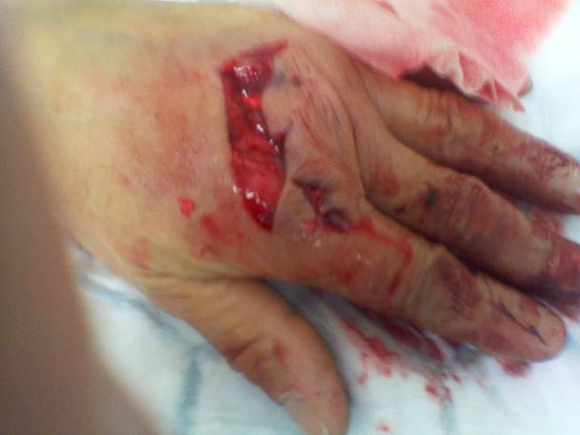  East Sussex Postman Glynn Page parked his Royal Mail Van in the driveway of a customer's house and got out to deliver the Mail. As he started walking towards the front door suddenly the side gate burst open and a dog ran at him, viciously attacking him and locking on to his left hand. He fell to the ground with the weight and force of the dog's attack and was shouting for help whilst the dog continued biting his hand. The owner then came out of the house and restrained the dog, pulling it off and ending the attack. Glynn underwent several operations on his damaged hand.
Alan Brown  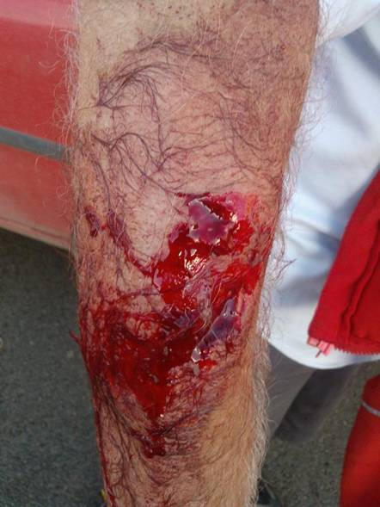  Durham Postman Alan Brown was performing his delivery round on 25 October 2013 when a dog scaled a 6ft fence from a property across the road from where Alan was delivering. The dog proceeded to launch a vicious attack him in the street badly injuring his arms and legs in a sustained attack. He suffered considerable blood loss from the pulsing, deep puncture and tear wounds before being rushed to hospital for emergency surgery to both arms and both legs. He was so badly injured he was unable to walk for some time after the attack. | Patricia Meddings  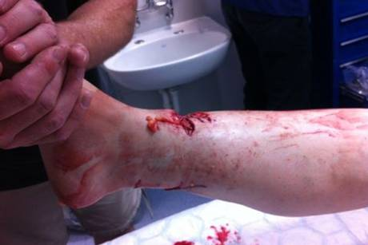  Holloway, North London Postwoman Patricia Meddings, feared for her life when she was set upon by the Japanese Akita in September 2013 and her leg was left “hanging by a thread” after the mauling in the savage dog attack. She needed two emergency operations to save her leg, a graft to replace the skin, and months of physiotherapy following the attack. The dog’s owner had previously been told to move his letterbox outside his garden fence and control his dog but he ignored it. The dog smashed through a barrier and attacked Patricia, clamping its jaws around her right leg. She had to fight the dog and drag it to a lamp post as it tried to take her down to the floor. The uninsured, unemployed benefits claimant owner was ordered to pay her £860 compensation at £10 per fortnight and banned from owning a dog for life. The dog was given a destruction order.

Paul Coleman  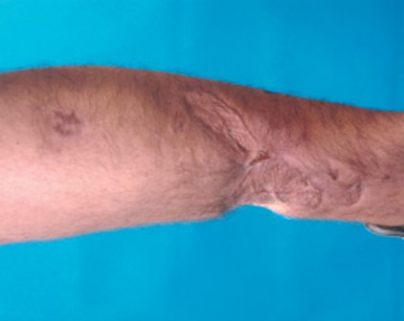 Sheffield Postman Paul Coleman was nearly killed in a December 2007 dog attack. Paul was mauled by two pitbull crossbreed dogs in a sustained attack as he was delivering Christmas mail. The two dogs escaped from an insecure property and attacked him, grabbing a leg each, dragging him to the ground and subjecting him to a horrifying prolonged attack. Paul suffered serious leg, arm and chest injuries and lost a significant amount of blood. Paul was in intensive care for six days. He underwent many skin grafts and plastic surgery operations over subsequent months. At one stage it was feared that he could lose his right arm but Surgeons managed to save it. Paul has permanent scarring and suffers reduced mobility along with lifelong disabilities and mental injury. | Alan Smith  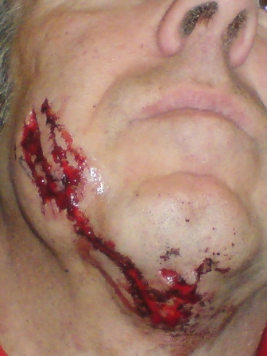  Milton Keynes postman Alan Smith needed over 100 stitched to his face after being attacked and badly bitten by a German Shepherd dog in February 2008, which attacked him after the owners young son opened the front door as the postman walked up the front path leading to the house to deliver the mail. The large dog barged past the child and launched a ferocious attack, knocking Alan Smith to the ground and clamping its teeth into his face and chin. The owner escaped punishment because of the loophole in the law at the time - prior to May 2014, whereby dog attacks on private property were not an offence. 70% - 75% of dog attacks on Postal Workers occur on private property.
Stuart Hughes  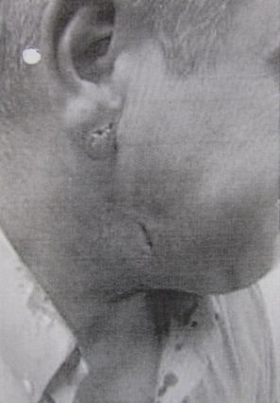  Gwynedd, Wales Postman Stuart Hughes almost lost his earlobe in autumn 2010 after an Alsatian rushed out of a house jumped at him, biting his jaw, ear and throat. The resident had seen the postman arriving and opened her front door in the north west Wales town. The dog stormed past her, launching an attack on the Postman before the owner manager to get the dog off him. | John Allanby  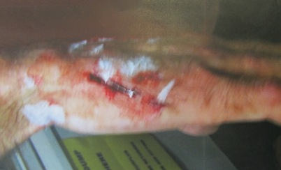  Leeds Postman John Allanby was off work a considerable time after being attacked by a German Shepherd dog which left him with deep wound puncture and tear wounds to his hand and arm which left him out of action for several months. John said "At this address, there is an open drive, with a gate to the back garden, but the gate had been left open and the dog ran out of the open gate and went straight for me and attacked me with force," The wounds still hurts and I have been left scared for life.

John Grainger  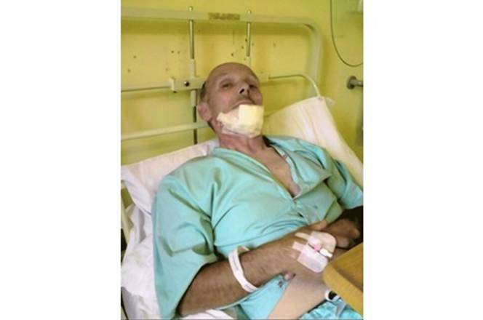  Chelmsford Postman John Grainger had finished his Delivery Round in August 2011 and was returning to collect his cycle in the Town Centre. As he bent down to unlock his cycle a Staffordshire Bull Terrier being walked off the lead by its owner rushed over and savagely attacked him ripping a large chunk of flesh out of his face and bottom lip. John had to undergo a series of operations and extensive facial reconstruction plastic surgery as a result of being savaged. After watching the attack, the dog owner casually walked off, leaving the badly injured, heavily bleeding postman on the floor. Fortunately, CCTV cameras captured the incident and the Police apprehended the dog owner who received a 9-month suspended jail sentence, 180 hours community service, a life ban from owning dogs and a Destruction Order was issued for his dog. | Alan Jack  Stirling, Scotland Postman Alan Jack, suffered serious facial and nose injuries after being attacked and bitten on the face by a dog. He suffered a horror wound to his nose in the attack as he did his rounds. Alan was bitten in Riverside’s Abbey Road. He received treatment at Stirling Community Hospital before being sent to the Plastic Surgery Unit at Glasgow General Hospital for surgery.
Stephen Carabine  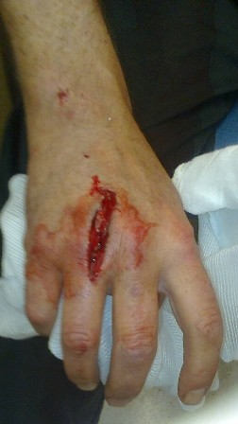  Belfast postman Stephen Carabine was opening the gate to  to a customer's front garden to deliver the mail when he was  suddenly, savagely attacked by a German Shepherd dog last  in June 2011. The dog bit right through his hand and locked  on. Stephen managed to struggle free and a local resident  called an ambulance, which took him to hospital where he  stitches in his wound. However, after being discharged, the  injury became infected and he had Cellulites up to his elbow  and was admitted to hospital where he received intravenous  Antibiotic treatment. As well as the stitches and the treatment  for the infection, Stephen also underwent physiotherapy from  a specialist plastics team. He has been left with total numbness on the back of his hand and has been advised that full feeling may never return. | Kieran Pickles  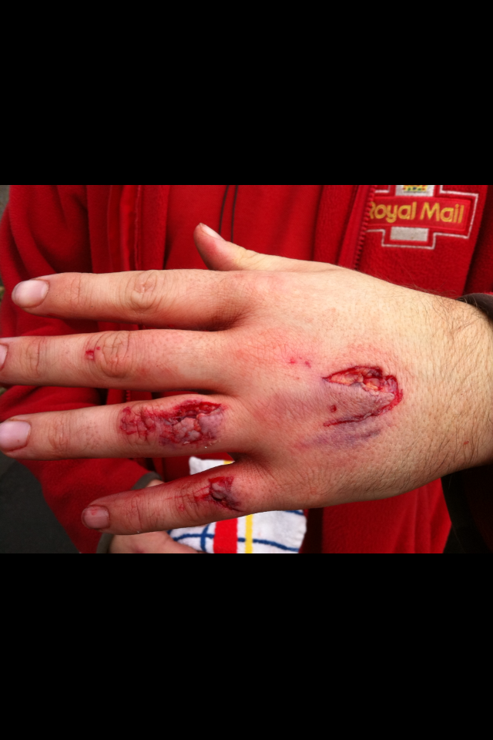  Dewsbury Postman Kieran Pickles went into an address as normal, opened the first gate to go down pathway, then as he opened second gate a dog came rushing out of house and attacked him, jumping up and grabbing hold of his left hand, causing deep lacerations to three parts of his hand. Kieran was taken straight to hospital and ended up staying in for 48 hours where he underwent surgery with internal and external stitches inserted along with treatment for infection.
Paul Roe  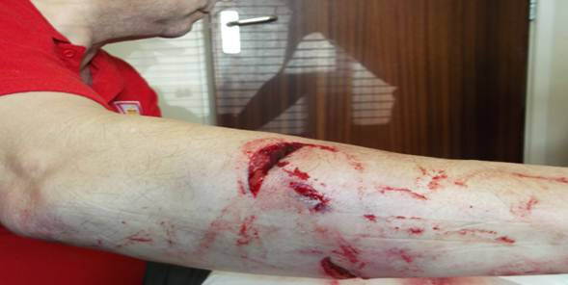  Chesterfield Postman Paul Roe was carrying out his delivery round on 8th April 2014 when he walked into cul-de-sac, Dickens Drive. An out of control American Bulldog was running loose and savagely attacked Paul inflicting serious injuries which included Muscle and Tendon damage to his right arm and bites and bruising to both inner legs. He was rushed to hospital where he underwent complex surgery with both internal and external stitches inserted. He was given strong antibiotics to avoid infection and needed long term treatment and rehabilitation a result of the mauling. |  | Stephen Oxtoby  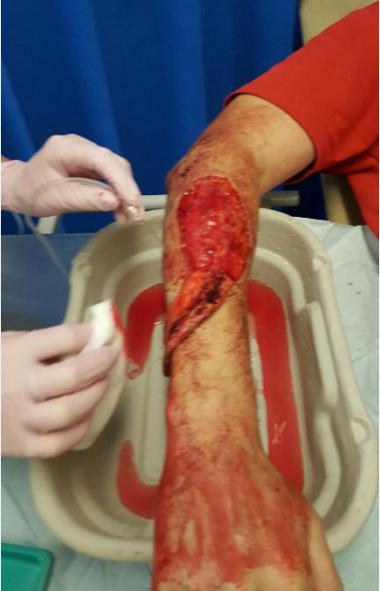  Manchester Postman Stephen Oxtoby had been carrying out his usual delivery round on 26 May 2015, in Radcliffe, Greater Manchester and was just leaving a property when he has noticed that a large Mastiff type dog was loose in the garden next door with two people standing at door. Stephen being aware of the dog from previous experience of carrying out deliveries to this address turned to walk away from the property. The animal as then proceeded to jump over the fence viciously attacking his right arm. The owners of the dog called the dog back but by this time Stephen had been badly injured and was taken the Royal Bolton Hospital where he underwent surgery and had his forearm stitched up.
Claire Offord  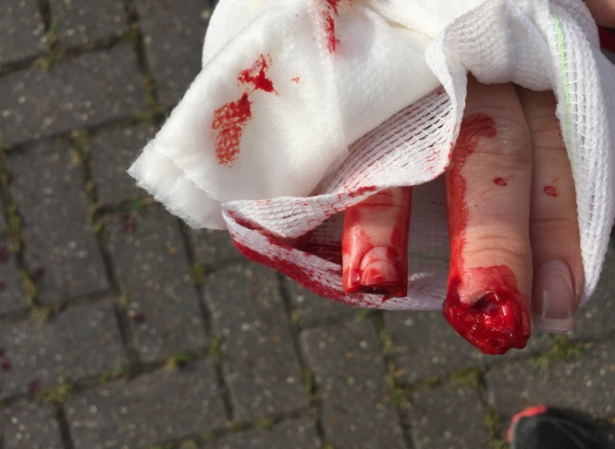  Romford Postwoman Claire Offord was attacked by a dog on the 23 February 2016 when without warning the Claire’s hand was savagely seized as she pushed mail through a front door letterbox. In a terrorising, ferocious attack the tips of her fingers were completely bitten off by a dog she couldn't see, inside the house. She was rushed to Hospital and underwent emergency plastic surgery and was medicated to avoid infection. Apart from physical injury Claire suffered physiologically. At the Magistrates Court on 6 May 2016, the dog owner pleaded guilty and was convicted an aggravated offence under the Dangerous Dogs Act 1991. He was ordered to pay Fines, compensation and costs totalling £8,793. A'Contingent' (Suspended) Destruction Order was imposed on the Dog and the Dog must Muzzled and have 'Mandatory' Third Party Liability Insurance cover for life. |  | Jackson Park Paul  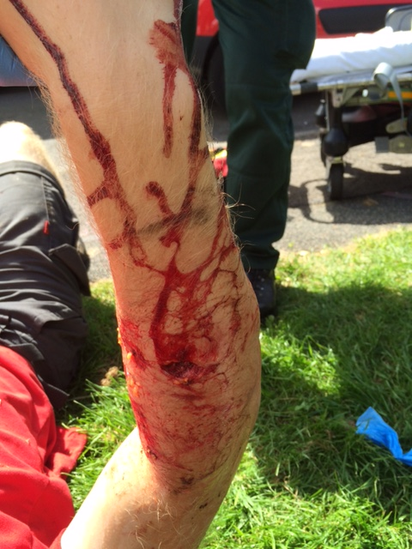  Huddersfield Postman Jackson Park Paul was walking along the road between delivery points in Meltham on 22 July 2016, when a dog jumped over the insecure back gate of a house he was passing, rushed at him and launched a savage, sustained attack, lasting several minutes during which time he was pulled to the floor, despite being a large man, well over 6 feet tall, indicating the dogs strength and the ferocity of the attack. The dog was finally made to release its grip on Jack and then dragged away following by the actions of a ‘good samaritan’ member of the public and nearby resident who rushed to Jackson’s aid repeatedly hitting the dog with a spade until it let go. A police armed response unit attended the scene after the dog had been taken back inside its home . The dog was subsequently seized and the owner was arrested and awaits trial.
Appendix 1
The UK Dangerous Dogs Problem -
In 2008 the CWU launched the ‘Bite Back’ campaign to get the Dangerous Dogs Act extended and to raise awareness about the epidemic scale of the problem of dog attacks on Postal Workers plus draw attention to the growing number of attacks on children and the public and the rapidly growing number of UK dog attack serious injuries and deaths.
- Two postal workers were nearly killed in dog attacks at Christmas 2007 and 2008 - 6,500 Postmen and Women attacked by dogs that same year.
- As a result the CWU launched its 'Bite Back' campaign (in 2008) aimed at getting changes to the Dangerous Dogs Act, as follows:-
1. Extending the Dangerous Dogs Act to protect people who are attacked on private property. 70 per cent of dog attacks on Postmen and Women are on private property where the owners were immune from prosecution.
2. Tougher sentences for those convicted of Dangerous Dogs Offences.
3. Dog Control Notices introduced as a preventative measure.
4. Extend Police powers in relation to the seizure of Dangerous Dogs.
5. Compulsory microchipping of all dogs in order to keep track of animals and their owners.

The CWU campaign achieved these objectives and is now focusing on:-
- Prevention.
- Consistent, tougher enforcement.
- Increased Police (Dog Legislation Officers) and Local Authority Dog Wardens resources.
- Raising public awareness of the issue of Dog Attacks and Dog Control problems.
- Promote better Dog Ownership Education and Training.

In the UK:-
• 34 dog attack deaths have occurred (31 since 2005) – 16 adults and 18 children
• 95,000 postal workers are on the UK streets six days a week 52 weeks of the year delivering 60 Million items to 29 million addresses daily.
• Online shopping is increasing the number of packages and parcels and 'signed for' deliveries. This is good for business but it's also increasing the dog attack risks to postal delivery workers who are having to regularly knock on doors and customers are having to open the door to collect and sign for their items. This means more delivery staff are at risk of coming into direct contact with dogs if the owner hasn't secured their animal before opening the door.
• 12-20 finger amputations occur a year for postal/delivery workers amongst other serious injuries from dog attacks.
• Letter Box Cages on the inside of doors to catch the post or outside post boxes can help reduce dog attacks which cause physical injury.
• 3,000-4,000 dog attacks a year occur on CWU members
• Approximately 1,000 minor dog attacks go unreported
• Summer holidays and the Christmas period see spikes in the number of dog attacks each year on Postal Workers. Summer because the kids are on holiday, the weather's good and the families are out and about in the garden at home with windows/doors open and the dogs are outside; Christmas because the number of deliveries doubles.

Further Changes the CWU would like to see:-
•Update and consolidate all the dog control legislation.
•Focus the Law on Dog Behaviour and not on Breed – Bad Irresponsible Ownership is the Issue.
•Ensure better, consistent enforcement. More Police DLO and More Dog Wardens.
•Provide extra resources to the Police for the training of more Dog Legislation Officers.
•Compulsory third party liability dog insurance which would help provide proper compensation for victims of dog attacks from the owners of the dogs. (The Dogs Trust Membership Scheme provides £1M Third Party Liability Cover for under 40p per week, 20p for over 60's - So it's not expensive).
•Reinstate the Criminal Injuries Compensation Scheme (CICS) Payments for Dog Attack Victims (abolished by the Tory/Lib.Dem Coalition Government).
• Dog Control Notices (DCNs) to be introduced to ensure early intervention with owners and their dogs help dog control by providing a simple preventative tool for Police and Local Authorities to serve on the owners of aggressive dogs in order to avoid serious incidents and attacks happening. The present Community Protection Notices (CPNs) are to complex, cumbersome, unspecific, slow and resource intensive.
• DCNs once served should also contain the minimum requirements of Third Party Liability Insurance, Microchip, Muzzle & Lead in Public, Owner & Dog Training.
•Those convicted of DDA Offences involving injury to face an automatic dog ownership ban of 10 years to life plus a Compensation Order in favour of the victim.
• The Control of Dogs Order 1992 mandates that any dog in a public place must wear a collar & Tag with the name and address (including postcode) of its owner engraved or written on it. A telephone number is optional (but strongly advisable). An owner can be fined up to £5,000 if the dog is not wearing this identification - This Law should be enforced with Fixed Penalty Notices and Court Fines for repeat offenders.
• The Government should run public awareness raising campaigns about the requirements of the Law.
• The Government should back a coordinated and well resourced national public education and training programme or responsible dog ownership and staying safe with dogs.

Dog attacks are preventable:-
Dog attacks are almost always preventable, if owners are responsible, keeping their animals under control and if initial signs of aggression are recognised and addressed immediately.

The growth in online shopping and signed for deliveries is resulting in Postal delivery workers having to knock on doors and for customers to open doors to collect and sign for the growing number of parcels which increases the possibility of direct contact with dogs in their own home or territory which they'll naturally defend.

To help reduce the number of dog attacks, owners need to increase their awareness of animal behaviour, take responsibility, recognise when their pet is showing signs of territorial aggression and take effective control.

Although Christmas and school summer holidays see a spike in dog attacks, on Postal workers, it’s important owners are observant as to a dog’s behaviour at all times and take action to maintain control both on their private property and in public.

By working together with dog owners, vets, CWU members, government, police, local authorities, animal charities - dogs and postal workers can live and work in harmony.

CWU/Royal Mail Dog Awareness Week in July -'Top Tips For Owners'
During the CWU/Royal Mail Annual Dog Awareness Week in July we promote our 'Top Tips for dog owners' when a postal/delivery worker comes to your door:-

1. Put your dog securely in another room before opening the door and avoid allowing children to open the door.
2. To prevent the risk of your dog biting the fingers of postal/delivery workers, fit a letterbox cage inside the door, or alternatively fit a secure outside mail box on the edge of your property.
3. Don't leave your dog unsupervised outside in an area where it may come in to contact with visitors to the property. (If it’s secured in the back then make sure it can't get round the side of the property and access the front garden or access path. Make sure it can't escape and get out on its own.
4. Never leave a dog alone with young children.

Dave Joyce National Health & Safety Officer
Communication Workers Union
150 The Broadway, Wimbledon, London SW19 1RX
Tel: 020 8971 7365/7308
E-Mail: djoyce@cwu.org
Mobile: 07974117512

Communication Workers Union

