IOSH IIRSM IIAI RSPH HSM January 2016

Criminals - a company director was fined £75,000 and sentenced to 12 months (suspended) imprisonment, if the fine is not fully paid within two years he faces 18 months imprisonment. A builder who removed asbestos insulating board without a licence was jailed for 6 months. In Blackburn businessman was sentenced to 24 weeks imprisonment (suspended) and £20,000 costs and his colleague £3,900 with 120 hours community work.

A company was fined £150,000 with £88,030 costs following the death of a worker who fell 2.5m – the judge said that the Risk Assessment was little more than cut-and-paste with no effective plan in place, an exercise in paperwork. Initial training was sufficient but there was no refresher training which is essential. Documents indicating spot checks were available but had these checks been conducted correctly in practice they would have identified the bad practice and rectified it.

PEROSH is a euro partnership to coordinate and cooperate on European research and development efforts in occupational safety and health. The network comprises of 12 OHS [i.e. HSL from UK] governments/authorities and health and accident insurance systems – see www.perosh.eu .

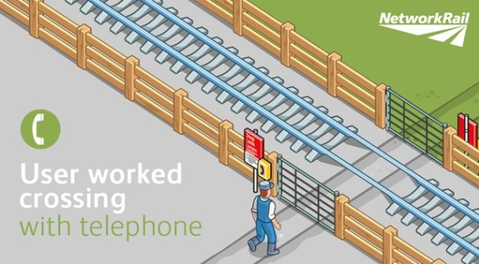Railway crossings – in the last 10 years 95 people have been killed [not suicides] on crossings, 23 in vehicles and 72 on foot; also consider the trauma of the witnesses and workers involved. There are 600 crossing but the 2281 user worked [UWC] ones raise the main concern. These can be passive such as no barriers or warning lights, usually in rural areas. In addition there are 2100 footpaths that may be used by our members to access remote dwellings for delivery or telephony, some require contact to be made to the rail signaller but some are sight only. NFU have some good information http://bit.ly/1fFzfwh, Network Rail on http://www.networkrail.co.uk/level-crossings/ and IOSH have a clip on UWC usage on youtube showing the correct way to cross at a rural railway crossing. Highlighting the importance of looking and listening, stopping distances and some of the hazards that can effect crossing safely.

Occupational Cancer – global estimate by EU-OSHA estimate that 32% of work related deaths are associated with cancers, in the EU that’s 53%. The ILO estimate that 666,000 deaths are attributable to work related cancer every year, double that of incidents, in the EU that’s 20 times that of incidents. The UK share is 13,330.

The IOSH “no time to loose” campaign continues to address cancer deaths with free resources available from www.notimetoloose.orh.uk – to date there have been over 25k downloads from the site.

A survey by Specsavers and BRAKE found that one in four drivers had not had a vision test in the past two years and that more than 1.5 million drivers have never had their eyes tested; and, one in eight need glasses admitted driving without them. See a free educational awareness video at http://www.brake.org.uk/sharpenup/story.html .

Investigating what went wrong is obvious but a good safety culture can be cultivated by investigating what went right.
For info on COSHH responsibilities there is a free online Chemical Safety Course for users of chemicals offered by R P Adam; the 30 minute interactive course takes participants through the necessary steps to understand the key aspects of using chemicals safely in the workplace. Identifying hazardous products, reduce risks with PPE, handling commercial cleaning detergents, the dangers of using chemical products inappropriately and the potential dangers of mixing products together http://rpadam.online/ .

Companies see safety as a cost of doing business or that which gets in the way when there is a production crunch on. “Running with Scissors” is a 60-page book that explains 10 reasons to invest in safety in slow times; free e-book from www.kevburns.com .
The IOSH guide to serious incident investigation “Learning the Lessons” was reviewed and updated in the summer and is free from http://goo.gl/0y5zih .

The IOSH “no time to loose” campaign continues to address cancer deaths with free resources available from www.notimetoloose.orh.uk – to date there have been over 25k downloads from the site.

Collated by Derek Maylor 5 January 2016.

IOSH IIRSM IIAI 0116

