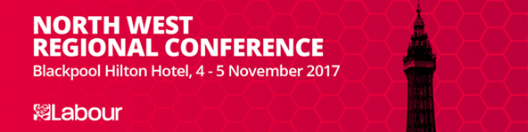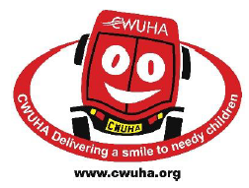
John McDonnell MP: Shadow Chancellor of the Exchequer. Imagine where we’d be if we had balanced coverage by the media, showing the real Jeremy Corbyn. There are 120,000 children are being brought up in temporary accommodation – we need council houses. We have two and a half million people waiting over four hours in A and E’s because of cuts whilst they push privatisation – we will end this and take back control of the NHS. We have students leaving university wills almost £50k of debt – we will end tuition fees and reinvest in Sure Start. Education will be from cradle to grave. Four million children are living in poverty, parents working but on poverty pay, using foodbanks in 2017, hardly a sign of a civilised society – this will end. Join a union, it’s not an option it’s vital to employment rights and to the economy. Pensioners died last winter because of fuel poverty, choosing between fire or food. The rich and corporations will pay their way, the loopholes that allow tax avoidance will be closed and it will go to end poverty and invest in society. A Tobin tax will raise money from the City on financial deals. A high skilled workforce will improve the economy, get workers higher pay and increase the money spent within communities. Legislation will be brought in to stop investment in London and the SE at the expense on the North West. We will stop fracking as part of decarbonising the economy, climate change is real. There will be a National Bank with regional arms to lead regional development. This is all in the manifesto; we must take this out to the communities where we live, develop it locally, how it will be implement locally. We will be the communities government not just the parties. A Labour Government, a socialist PM, a mass movement and a growing party; “ I have waited a lifetime for this.”
Nearly half of the new jobs created in the North West have been in insecure lines of work such as zero hours contracts, temporary or casual work or low paid self-employment. This sort of employment it impossible for families to plan for the future, or buy a home when at any stage their income can stop. In these workplaces unions are often not recognised and employees can be scared to raise issues such as safety concerns or they may lose their job. Labour will confront abuse and neglect of working people and provide a better future under the “Fair Deal at Work”.

During the European debate were noted six red lines during Brexit negotiations and the aftermath;
- Parliament not ministers must have the final say on whether to approve the withdrawal agreement and, if so, how to implement it.
- May's Florence speech highlighted a 2 year implementation period – this to be added to face of the Bill.
- An end to Henry VIII powers that allows ministers to make big legislative changes regarding Brexit with little parliamentary scrutiny.
- Ensure that the devolution settlement in the Bill devolves powers to Cardiff, Belfast, and Edinburgh not keeping it in Whitehall.
- The Bill must entrench EU Charter on Fundamental Rights in protection after leaving.
- EU derived workers' rights & environmental standards must be guaranteed on the face of the Bill so the UK does not fall behind Europe.

Dianne Abbott the Shadow foreign secretary opened saying that there is no greater task for government than protecting its people, addressing the terrorist threat; however you cannot keep people safe on the cheap. It starts with properly funded neighbourhood policing. There are 20,000 less police than there were in 2010. The Prevent programme, this should not be about doing things to a community but about doing things with the local community, all of it not just a selected group, an instrument by people for people. Immigration, most of the media stories are myths – predatory employers, globalisation, weakening of union rights drive down wages not immigrants.

Recognising the threats posed by fossil fuel production and climate change and that the economy is suffering from a lack of investment, underemployment and low productivity. Labour will address these issues by creating a plan for a Green New Deal that would transform the UK to a low carbon, sustainable economy. This will involve large scale investment in the renewable energy industry and energy and resource efficiency, creating thousands of skilled and unskilled jobs in the renewable energy industry, ensuring that fossil fuel prices reflect the cost to the environment, re-regulate the finance sector to ensure investment is socially valuable and reregulated.

In September 2017, NHS Providers, the trade association that represents hospital, mental health, community and ambulance trusts in the North West of England, called for an immediate investment of cash in the health service to avoid risks to patient safety over the coming winter months as local services struggle to cope with competing pressures and will not be able to manage. The short term and inadequately funded responses given by the Tory Government must not be allowed to continue.

There is growing public concern in the North West over the continuing crisis in social care, particularly following recent reports of another winter crisis within the health service and insufficient government funding. This is an ongoing issue that touches every person of our communities in the North West, including the most vulnerable and we welcome UNISONs Care Workers for Change campaign initiative. This will encourage all local authority commissioned care services in the North West to respect the right of staff to organise trade union representation including allowing access to accredited union representatives and officials to speak to staff for the purpose of recruitment to a trade union; ensure that a Labour Government introduces measures that provide adequate funding to enable local authorities to achieve standards of care that are fit for purpose; develop the Manifesto commitment to create a National Care Service.

As part of the Sustainability & Transformation Partnerships (STPs), in particular the Our Health Our Program, the Care solution design process for Central Lancashire have stated their key message and proposals to clinicians are to accelerate roll out of new care models on a large scale, to be risk averse and not to be afraid to take risks by trying something new, told it's ok to fail as long as they are seen to be doing something. This is not evidenced based. There is also wide concern that patient safety is placed at risk by utilising a high-risk trial and error approach by indicating they wish to maintain the momentum by starting to implement some of the changes quickly and then learning and tailoring our approach as they go. Further proposals to separate non-acute services from local hospitals into as yet non-existent community clinics when the solutions design team themselves confirm that at present they do not have the manpower, staff or funding to implement this. Furthermore the proposal to close and separate out some hospital services into communities without undertaking in-depth risk assessments and quality impact assessments will seriously destabilise other hospital and primary care services and further risk patient safety. It was agreed to oppose any further roll-out of care models in Central Lancashire until it has been shown any service model proposed are fully resourced, shown to be working efficiently and effectively before closure or downgrade of any existing service models, and the public have been fully consulted on the plans.

As we are all aware, the government’s ongoing discrimination of the poor and disabled appears to be never ending. As a country, we are suffering from record levels of poverty, which are rising every day. Even if we were successful in winning the next general election, it would take the country many years to recover and the ramifications of this would continue for years to come. Because the issues surrounding poverty are immense and complicated there needs to be a minister appointed to deal with specifically as a matter of ongoing importance and urgency. We therefore propose that the Labour Party for the next Labour Government appoints a minister for poverty, elected to deal with and to counter the rise in poverty.

Credit Unions are small community Co-operative Banks whose lending philosophy is based on ethics and responsible lending. Credit Unions are an excellent means of encouraging thrift whilst at the same time providing loans at fair interest rates to local communities across our region. Credit Unions protect often-vulnerable people from being forced to borrow from Pay Day lenders or even worse unregulated unethical and sometimes violent doorstep lenders. Conference therefore calls on all LA’s, Metro Mayors, Housing Associations, health Services, Trade Unions and other agencies to do all in their power to support, protect and grow this very valuable Co-operative Banking system.
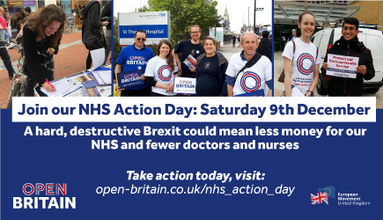Brexit as the most “serious crisis” Britain has faced since the Iraq war. As Brexit unfolds in Brussels, people are concerned about the damage that a hard and destructive Brexit could do to our NHS and are worried that since the referendum, there has been a 96% drop in the number of EU nurses registering to work in Britain. This is on top of the existing 30,000 shortage of nurses we have in England alone. The fantastic contribution made to our NHS by doctors, nurses and other healthcare professionals could not have been achieved without professionals from across the EU coming to work here. The rights of all EU citizens including those working in the NHS must be guaranteed immediately.
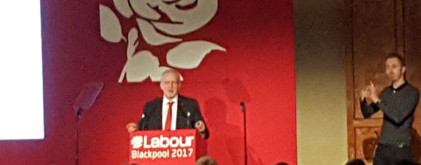Rebecca Long-Bailey introduced Jeremy Corbyn, most of his words will be reported in the general media however there were inspirational highlights. Voting Labour isn’t just to make things a bit better it is to change lives – another world is possible. National Education Service will offer education for whole life whatever your station, wherever you’re from, free. JC said he felt humbled by the love, humanity and solidarity showed by people when in Manchester after the bombing. It is easy to praise the emergency services at this point but Labour will priorities giving them the resources to do their job. The North West has the highest Labour vote in the country, showing the rest of the country we can change the things that matter to people, we are winning the arguments. The pain and misery the Tories have put the country through has been for nothing. We will have a publically owned rail system working for people not profit. We will roll out super-fast broadband. We will renationalise Royal Mail. We want a jobs-first people based Brexit not a slash and burn run away. We are looking at alternative ownership models for the digital age. We will have a society that improves everyone’s lives not just a few winners but to do it we have battles to win and cases to fight
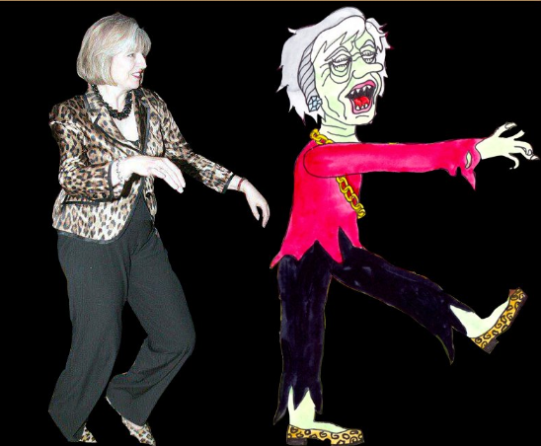
Derek Maylor
safety@cwumswl.org
6 November 2017

