Health and Safety event – Understanding Stress
1st.March 2017
Steve Pepper opened meeting noting the stress has serious implications for both the business and employees. Under the Health and Safety at Work etc Act 1974 there is a duty to ensure the health of employees including stress.
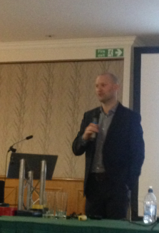Mark Nixon, Senior Safety Consultant from Arco, spoke about the way the mind physically reacts to stress. Just sending people home no worse than they came in to work is fine but can send them home better than they came in should be the aim, they will feel better; they will work better for you. Mental Health First Aid is now a big issue such as the “Mates in Construction” scheme currently being rolled out across the construction industry. What we say to ourselves massively affects the way we feel and the way our body reacts to situations, for example, Usain Bolt doesn’t crouch down before a race thinking “I’m going to come last here”.
It is interesting to note that the HSAWA section 1(1) a there is a duty to securing the health of persons at work, not merely to “make sure do not worsen” their health. There is also case law to take extra measures for the more vulnerable workers so the is enhanced duty of care to pregnant women or aging workers for example [which may be of use in EMF prop to conference]. Wellbeing is a skill and as such it can be learned and enhanced.
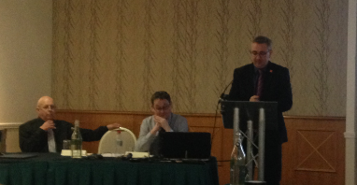The Director of Corporate Affairs from Yorkshire Water, Richard Sears, gave a very personal story of a decent into chronic depression that crept in over a two year period, the resulting health breakdown, the chaos it caused for him and his whole family – not going to expand as seems intrusional.

Alison Wilson is a leading Life Coach and opened with the dreaded word, resilience. The issue is not the amount of stress that a worker is under but how they react and recover to that stress, it varies from worker to worker and importantly overlooked even the same worker will vary from day-to-day. Just because he/she was ok with it last week you cannot assume that they are ok with it this week, they may have lost a family member over the weekend. Employers and managers have to be looking for significant behavioural changes constantly; presenteeism does not help the business and certainly does not help the employee.
Susan Gee is Occupation Health Manager for Yorkshire Water, a lecturer at Leeds Beckett and former Head of Occupational Safety at Bradford MBC. She talked about the need for robust strategies. If something is leaking it is fixed ASAP and if a staff member is ill that should be fixed just as quickly. We need to keep people in work in the long term and that may mean giving them time off in the short term. It is ridiculous to expect workers to leave all their problems at the gate or front door when they come in to work at 8 o’clock, it is impossible and employers should work with trade unions and the workforce whatever the issues are to support them it makes simple business logic.

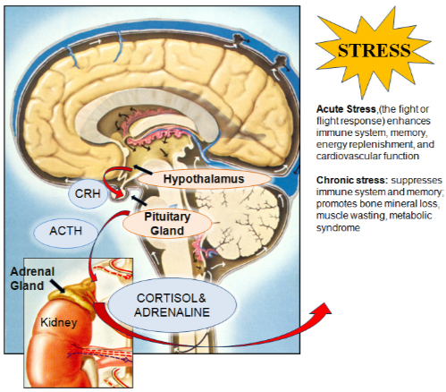[a]
Cortisol is a steroid hormone known to be involved in many negative health effects, mental health and decreased resilience. It is a glucocorticoid hormone which helps to metabolise glucose, fats and proteins. So if over produced there is a physical effect on the body.
Even though this was over in Harrogate our invites started via the HSE so they could add some union people rather than be 100% business so we have been attending these events for many years now and they are always useful, it is also an opportunity to put CWU and union point over at times to a business group. However this was the first time that working with unions has had so many mentions from the speakers that I didn’t even ask a question.
There is a useful handout that could go into a mailshot as long as it is acknowledged as being from ARCO.
Derek Maylor 07761 098 993

[a] Walton, Alice G.. (2010). What Stress Does To You. Available: http://www.thedoctorwillseeyounow.com/content/stress/art2861.html. The Stress Response and the HPA Axis. Last accessed 2 March 2017.
Harrogate 0317

